Apache Airflow – Assignment - Lokanya G
Step 1: Install docker exe from google, choose Download for Windows-AMD64
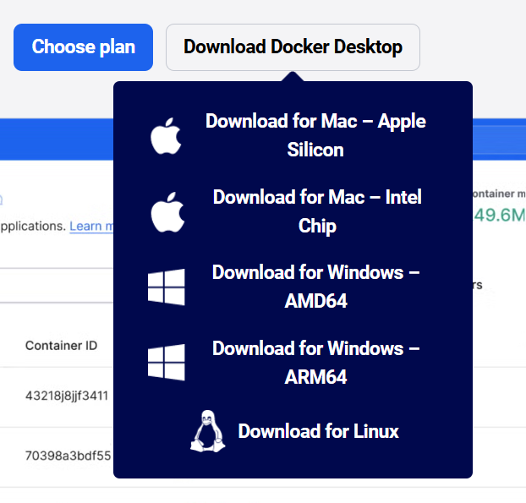
Step 2: Double click on the exe file you downloaded and after the process gets completed restart you system.
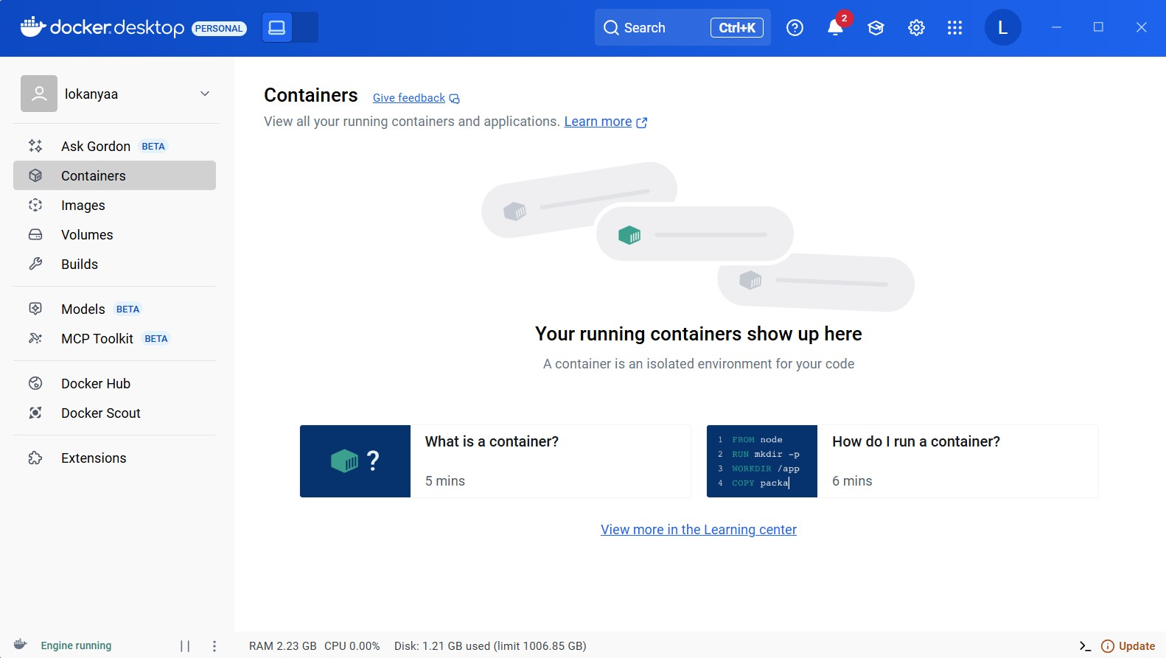
Step 3: Open this location “C:\Users\user name\materials” and paste the ‘docker-compose.yaml’ file in it.
Step 4: Now right click on the file and open with vs code(open a folder), in the vs code folder create ‘.env’ file and paste the below command .

AIRFLOW_IMAGE_NAME=apache/airflow:2.4.2
AIRFLOW_UID=50000
Step 5: Again in vs code on the same location open a new terminal and run the below command.
docker-compose up -d
Step 6: Open chrome and type ‘localhost:8080’ ,Docker UI window will open then you have to enter the password and username and login .’
Step 7: Now the final Docker workpage gets opened.
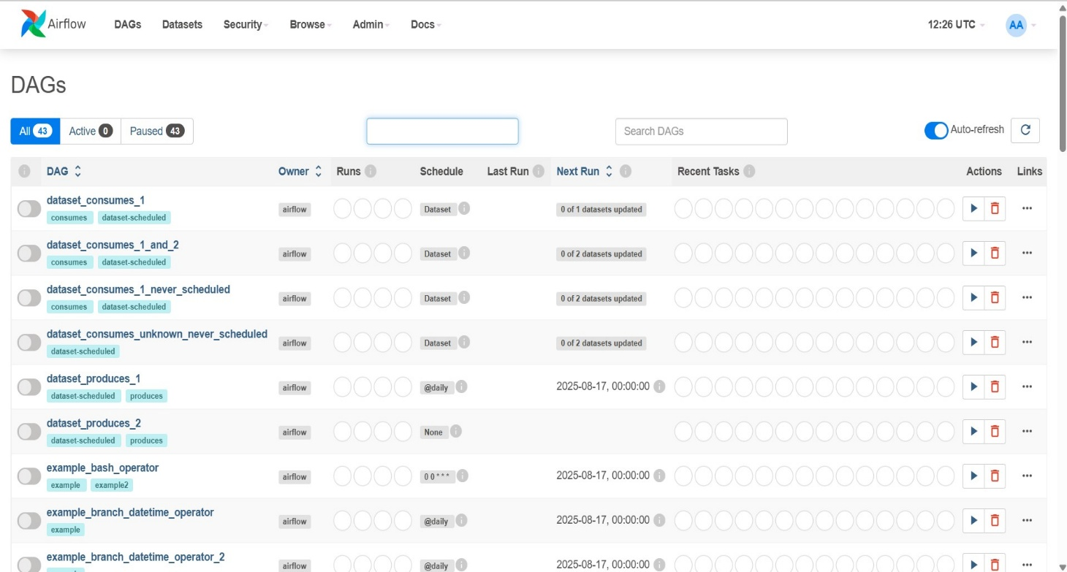
Docker page after setup done in chrome.
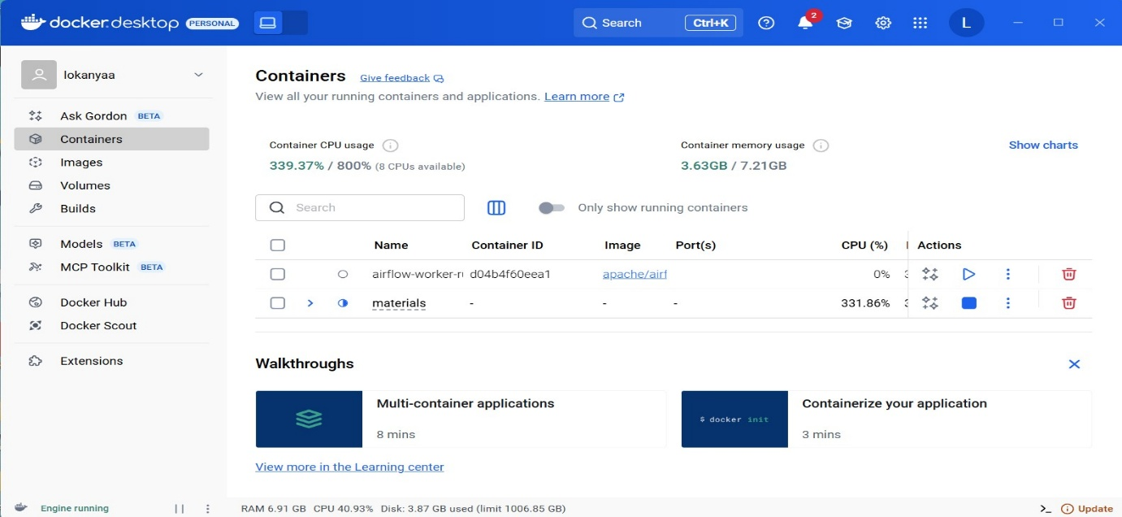
Building a Simple Data Pipeline
Create a Postgres Connection
Before our pipeline can write to Postgres, we need to tell Airflow how to connect to it. In the UI, open the Admin > Connections page and click the + button to add a new connection.
Fill in the following details:
- Connection ID: tutorial_pg_conn
- Connection Type: Postgres
- Host: postgres
- Database: airflow (this is the default database in our container)
- Login: airflow
- Password: airflow
- Port: 5432
Save the connection. This tells Airflow how to reach the Postgres database running in your Docker environment.
Next, we’ll start building the pipeline that uses this connection.

Create tables for staging and final data
Let’s begin with table creation. We’ll create two tables:
- employees_temp: a staging table used for raw data
- employees: the cleaned and deduplicated destination
We’ll use the SQLExecuteQueryOperator to run the SQL statements needed to create these tables.
You have to save the code in the ‘materials’ location under dags and name it as process_employees.py.

CODE:
from airflow import DAG
from airflow.providers.sqlite.operators.sqlite import SqliteOperator
from datetime import datetime

with DAG(
dag_id="process_employees_dag",
start_date=datetime(2023, 1, 1),
schedule_interval=None,
catchup=False,
) as dag:

create_employees_table = SqliteOperator(
task_id="create_employees_table",
sqlite_conn_id="my_sqlite_conn",
sql="""
CREATE TABLE IF NOT EXISTS employees (
id INTEGER PRIMARY KEY,
name TEXT,
department TEXT
)
""",
)

create_employees_temp_table = SqliteOperator(
task_id="create_employees_temp_table",
sqlite_conn_id="my_sqlite_conn",
sql="""
CREATE TABLE IF NOT EXISTS employees_temp (
id INTEGER,
name TEXT,
department TEXT
)
""",
)

create_employees_table >> create_employees_temp_table

After this step you will see the process_employees dag name in the DAGs
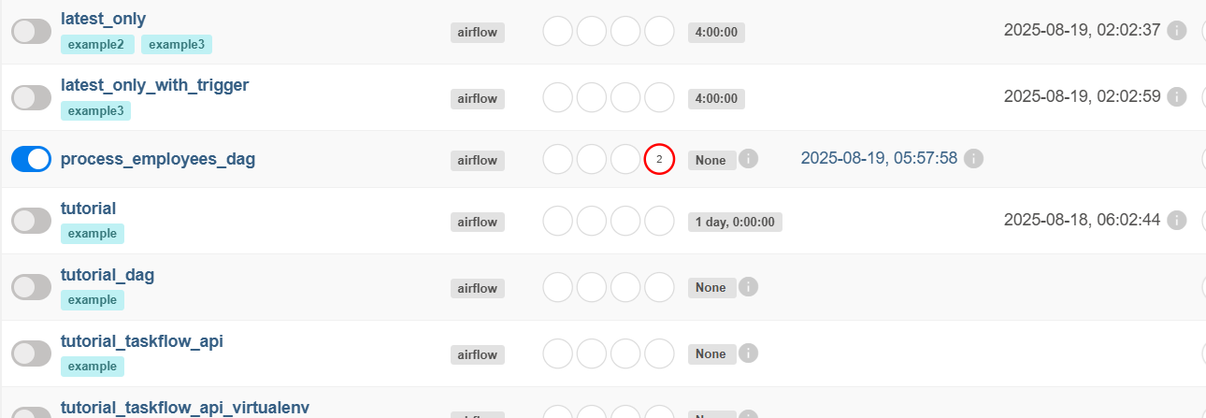

Load data into the staging table
Next, we’ll download a CSV file, save it locally, and load it into employees_temp using the PostgresHook.
Then modify the code in process_employees.py like below for Loading data:
from datetime import datetime
from airflow import DAG
from airflow.providers.postgres.operators.postgres import PostgresOperator
from airflow.decorators import task
from airflow.providers.postgres.hooks.postgres import PostgresHook
import os
import requests

# Task to download CSV and load into Postgres
@task
def get_data():
data_path = "/opt/airflow/dags/files/employees.csv"
os.makedirs(os.path.dirname(data_path), exist_ok=True)

# Download CSV
url = "https://raw.githubusercontent.com/apache/airflow/main/airflow-core/docs/tutorial/pipeline_example.csv"
response = requests.get(url)
with open(data_path, "w", encoding="utf-8") as file:
file.write(response.text)

# Load into Postgres
postgres_hook = PostgresHook(postgres_conn_id="tutorial_pg_conn")
conn = postgres_hook.get_conn()
cur = conn.cursor()
with open(data_path, "r", encoding="utf-8") as file:
cur.copy_expert("""
COPY employees_temp FROM STDIN WITH CSV HEADER
DELIMITER ',' QUOTE '"'
""", file)
conn.commit()
cur.close()
conn.close()

with DAG(
dag_id="process_employees_dag",
start_date=datetime(2023, 1, 1),
schedule_interval=None,
catchup=False,
) as dag:

# Create employees main table
create_employees_table = PostgresOperator(
task_id="create_employees_table",
postgres_conn_id="tutorial_pg_conn",
sql="""
CREATE TABLE IF NOT EXISTS employees (
id INTEGER PRIMARY KEY,
name TEXT,
department TEXT
)
""",
)

# Create employees temp table
create_employees_temp_table = PostgresOperator(
task_id="create_employees_temp_table",
postgres_conn_id="tutorial_pg_conn",
sql="""
CREATE TABLE IF NOT EXISTS employees_temp (
id INTEGER,
name TEXT,
department TEXT
)
""",
)

# Run tasks in sequence
create_employees_table >> create_employees_temp_table >> get_data()

Then trigger the dag again to see the updation done via code .
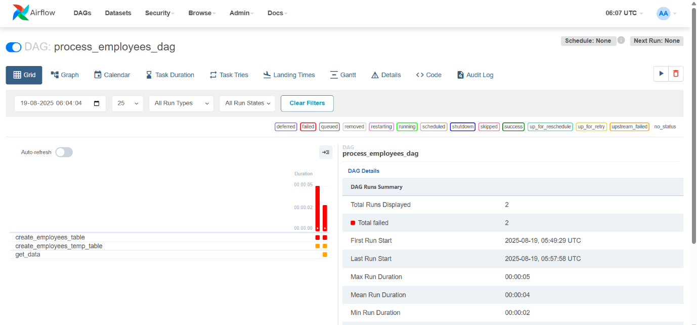
Now create an employees.csv file in the location ~/materials/dags/data/employees.csv
Merge and clean the data
Now let’s deduplicate the data and merge it into our final table. We’ll write a task that runs a SQL INSERT … ON CONFLICT DO UPDATE.
Modify the code in process_employees.py file like below:
from datetime import datetime
from airflow import DAG
from airflow.providers.postgres.operators.postgres import PostgresOperator
from airflow.decorators import task
from airflow.providers.postgres.hooks.postgres import PostgresHook
import os

# Task to load CSV into Postgres
@task
def get_data():
data_path = "/opt/airflow/dags/employees.csv"
if not os.path.exists(data_path):
raise FileNotFoundError(f"{data_path} not found. Please place employees.csv there.")

# Load into Postgres
postgres_hook = PostgresHook(postgres_conn_id="tutorial_pg_conn")
conn = postgres_hook.get_conn()
cur = conn.cursor()
with open(data_path, "r", encoding="utf-8") as file:
cur.copy_expert("""
COPY employees_temp FROM STDIN WITH CSV HEADER
DELIMITER ',' QUOTE '"'
""", file)
conn.commit()
cur.close()
conn.close()

with DAG(
dag_id="process_employees_dag",
start_date=datetime(2023, 1, 1),
schedule_interval=None,
catchup=False,
) as dag:

# Create employees main table
create_employees_table = PostgresOperator(
task_id="create_employees_table",
postgres_conn_id="tutorial_pg_conn",
sql="""
CREATE TABLE IF NOT EXISTS employees (
id INTEGER PRIMARY KEY,
name TEXT,
department TEXT
)
""",
)

# Create employees temp table
create_employees_temp_table = PostgresOperator(
task_id="create_employees_temp_table",
postgres_conn_id="tutorial_pg_conn",
sql="""
CREATE TABLE IF NOT EXISTS employees_temp (
id INTEGER,
name TEXT,
department TEXT
)
""",
)

# Merge data from temp into main table
merge_data = PostgresOperator(
task_id="merge_data",
postgres_conn_id="tutorial_pg_conn",
sql="""
INSERT INTO employees (id, name, department)
SELECT DISTINCT id, name, department
FROM employees_temp
ON CONFLICT (id) DO UPDATE
SET
name = EXCLUDED.name,
department = EXCLUDED.department;
""",
)
# Run tasks in sequence
create_employees_table >> create_employees_temp_table >> get_data() >> merge_data
